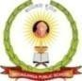

SRI SIDDAGANGA HIGHER PRIMARY SCHOOL
(Affiliated to CBSE New Delhi)
1st Stage II Phase, Chandra layout Bangalore72.
MIDTERM EXAMINATION, 2025-26
DATE: 20-09-25 Subject: Environmental Studies MAX MARKS: 50 Class: III TIME: 2 ½hrs
Name: Roll No: Sec:_____________

Observation | Knowledge | Understanding | Skill | Total
08 | 12 | 26 | 04 | 50

General instructions:
- Handwriting should be legible.
- Avoid over writing

OBSERVATION
- Observe the picture and answer the following questions. 1X5=5

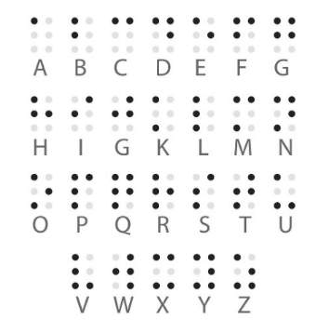
- What is the Script used by visually impaired people called
Ans: ____________________________________________________________
________________________________________________________________
________________________________________________________________

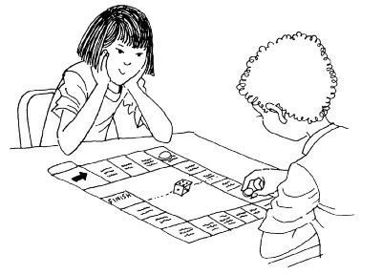 | 2. Define indoor games and give 2 examples  Ans: _____________________________________________  __________________________________________________  __________________________________________________

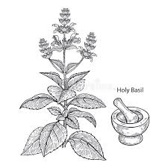
3. What are evergreen trees?
Ans:_________________________________________
_____________________________________________
_____________________________________________

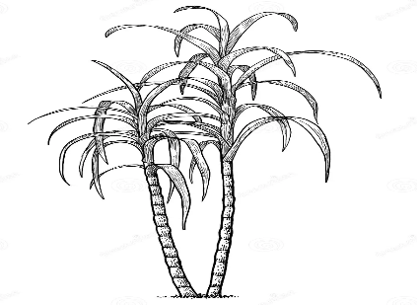 | 4. Sugar is made from which plant?  Ans: _________________________________________  ______________________________________________  ______________________________________________

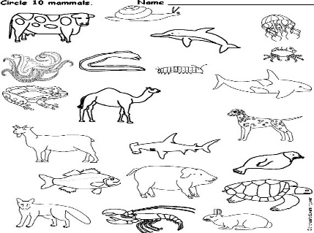 | 5. what are mammals?  Ans: _________________________________________  ______________________________________________  ______________________________________________

II. Complete the Analogy. 1X3=3

1. Herbivores: Cow :: Carnivores : ________________________.

2. SSA: Serva Shiksha Abhiyan :: ILO:

3. Cricket : Outdoor game :: __________________: Indoorgame
KNOWLEDGE
III. Fill in the blanks. 1X6=6

1. ________________________ are our parents father and mother.

2. Natural ability to do something is called ___________________________.

3. Each type occupation requires specific _____________ and ___________________

4. Pulses are rich in _______________________

5. A leaf is attached to the stem by ____________________

6. The flat green part of leaf is called _____________
IV. Match the following. ½ X4=2

 | A | B
1 | Ducks | Wings
2 | Butter | Webbed feet
3 | Tree | Fat
4 | Birds | Oxygen

V. Directions: In the following question, a statement of Assertion (A) is followed
by a statement of Reason (R) . 1X1=1
Mark the correct choice.

a) Both A and R are true and R is the correct explanation of A.
b) Both A and R are true and R is the not correct explanation of A.
c) A is true but is false.
d) A is false but R is true.

Assertion (A) : Leaves are called as food factory.

Reason (R) : Leaves prepare food for the plant.

VI. Case study based Questions. 1X3=3

Vehicles that run on land are called means of land transport. Roadways is a
network of roads on which vehicles move . Vehicles such as buses, truck, bicycles
are means of road transport. Railways is a network of tracks on which trains move.
Some trains carry people to different parts of the country. These are called passenger
Trains. Some trains carry goods or different things from one place to another. These
are called goods trains.
1. What do you mean by roadways ? Give examples.
Ans:_______________________________________________________________
___________________________________________________________________
___________________________________________________________________
2. What is a passenger train?
Ans:_______________________________________________________________
___________________________________________________________________
___________________________________________________________________
3. Which was the first train that ran in India?
Ans: ______________________________________________________________
___________________________________________________________________
UNDERSTANDING
VII. Answer the following questions in one sentence each. 1X6=6
1. Why do all living things depend on plants?
Ans:_______________________________________________________________
___________________________________________________________________
___________________________________________________________________
2. Name 2 mammals that live in water?
Ans:_______________________________________________________________
___________________________________________________________________
___________________________________________________________________
3. Name some parts of birds body?
Ans:_______________________________________________________________
___________________________________________________________________
___________________________________________________________________

4. How are honeybees helpful?
Ans:_______________________________________________________________
___________________________________________________________________
___________________________________________________________________

5. Define photosynthesis?
Ans:_______________________________________________________________
___________________________________________________________________
___________________________________________________________________
6. What is recreation?
Ans:_______________________________________________________________
___________________________________________________________________
___________________________________________________________________
VIII. Answer the following questions in two or three sentences. 7 X2=14
- How can we help the elderly?
Ans:_______________________________________________________________
___________________________________________________________________
___________________________________________________________________
2. What do you understand by child labour?
Ans:_______________________________________________________________
___________________________________________________________________
___________________________________________________________________
3. Describe the function of chlorophyll.
Ans:_______________________________________________________________
___________________________________________________________________
___________________________________________________________________

4. Write 2 examples of fibers we get from plants?
Ans:_______________________________________________________________
___________________________________________________________________
___________________________________________________________________
5. What is incubation?
Ans:_______________________________________________________________
___________________________________________________________________
___________________________________________________________________
6. How is the moth different from butterfly?
Ans:_______________________________________________________________
___________________________________________________________________
___________________________________________________________________
7. What are nutrients?
Ans:_______________________________________________________________
___________________________________________________________________
___________________________________________________________________
IX. Answer the following questions in four sentences each. 3X2=6
1.Explain the Photosynthesis.
Ans:_______________________________________________________________
___________________________________________________________________
___________________________________________________________________
___________________________________________________________________
2. Name three types of feathers?
Ans:_______________________________________________________________
___________________________________________________________________
___________________________________________________________________
____________________________________________________________________

SKILL
X. Locate any four given places in outline map of India and colour the places.
1X4=4
1. Karnataka 2. West Bengal 3.Ladakh 4.Rajasthan 5. Andhra Pradesh
